**Transmission Line Simulation**

**Using the Finite Difference Time Domain Method**

**Derek Swanson, John R. Natzke, Ph.D.**

**Department of Math, Computer Science, and Engineering**

**George Fox University**

**Newberg, OR**

1. **Introduction**

Electrical circuits are typically modeled as a network of lumped elements connected by ideal conductors. The connections are assumed to be ideal in the sense that the voltage is uniform throughout the conductor and that the current entering the conductor is balanced by an equal current exiting the conductor. However, these assumptions break down at high frequency due to the non-ideal characteristics of the physical materials and geometry. Recall that frequency is inversely proportional to wavelength. At low frequency, the wavelength is usually much greater than the dimensions of the physical conducting structure, so it is safe to assume that the voltage is the same everywhere on the conductor. At high frequency, the wavelength is comparable to or smaller than the dimensions of the physical conducting structure, so the voltage becomes dependent on position within the conductor. Therefore, it becomes necessary to model the conductor as a transmission line. A general representation of a 1-dimensional transmission line is shown in Figure 1 below.

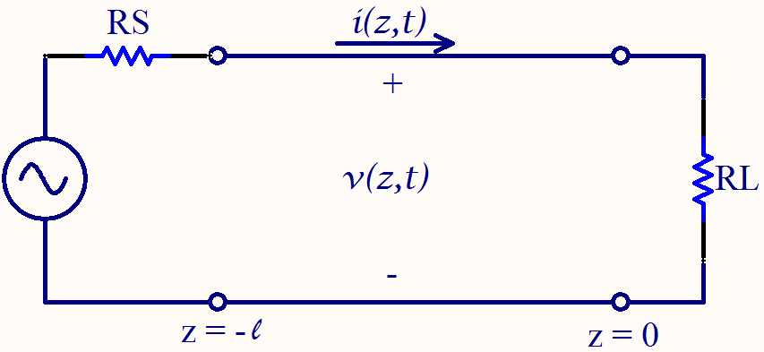

**Figure 1:** Transmission line connecting a voltage source to a resistive load. Note that the voltage and current are functions of the spatial dimension, z.

The transmission line model takes into account the per-unit-length capacitance $(C^{'})$, inductance $(L^{'})$, resistance $(R^{'})$, and conductance $(G^{'})$. These are distributed values derived from the material properties and geometric structure of the transmission line. The voltage and current along the line are then described by a pair of partial differential equations, as derived in [3]:

|  |  |  |
| --- | --- | --- |
|  | $$-\frac{∂i(z,t)}{∂z}=v{(z,t)G}^{'}+C'\frac{∂v(z,t)}{∂t}$$ | (1) |
|  | $$-\frac{∂v\left(z,t\right)}{∂z}=i(z,t)R^{'}+L'\frac{∂i(z,t)}{∂t}$$ | (2) |

The derivatives in equations (1) and (2) can be approximated with centered finite differences, as shown in equations (3) and (4).

|  |  |  |
| --- | --- | --- |
|  | $$-\frac{i\left(z_{m+1}\right)-i(z_{m-1})}{∆z}=vG^{'}+C'\frac{v\left(t_{n+1}\right)-v(t_{n-1})}{∆t}$$ | (3) |
|  | $$-\frac{v\left(z_{m+1}\right)-v(z_{m-1})}{∆z}=iR'+L'\frac{i\left(t_{n+1}\right)-i(t_{n-1})}{∆t}$$ | (4) |

Equations (3) and (4) can easily be solved for the “next” values, $v\left(t_{n+1}\right)$ and $i(t_{n+1})$, in terms of the “previous” values, $v\left(t_{n-1}\right)$ and $i\left(t_{n-1}\right).$ Given a set of initial conditions, the entire transmission line can be solved for one instant in time. Then those results can be used to solve the entire transmission line for the next instant in time (i.e. one time step later). Thus, the solution is computed step-by-step in the time domain, hence the term Finite Difference Time Domain (FDTD). This iterative technique naturally lends itself to computer simulation. However, since equations (3) and (4) are only approximations of equations (1) and (2), such a computer simulation can suffer from numerical error and instability.

1. **Objectives**

The purpose of this research was to develop techniques for improving the accuracy of 1-dimensional transmission line simulations using the FDTD method. Specifically,

* To investigate numerical artifacts such as the “rounding” of square pulses.
* To develop a more accurate set of boundary conditions at the source and load.
* To investigate the effect on accuracy of higher-order derivative approximations.
* To investigate the accuracy and stability of different solution configurations, including the *collocated* technique, where discrete voltages and currents defined at same locations in space and time, as well as the *un-collocated* technique, where discrete voltages and currents are staggered in space and time.
* To investigate situations where the per-unit-length parameters ($C^{'}$, $L'$, $R'$, and $G'$) vary with position along the transmission line.

1. **Methods**

A computer program was written in MATLAB to simulate the transmission line shown in Figure 1 by solving equations (1) and (2) using the FDTD method. The user specified the per-unit-length parameters ($C^{'}$, $L'$, $R'$, and $G'$), as well as the length of the line. Then, the program solved for the discrete voltages and currents along the line, plotting the results after each time iteration. This created the illusion of a moving wave, as shown in Figure 2. In order to solve the entire transmission line, boundary conditions had to be developed at the source and at the termination. The boundary condition at the termination took into account the $V=IR$ relationship forced by the termination resistance. The boundary condition at the source took into account a similar $V=IR$ relationship across the source resistance, thus connecting the transmission line to the excitation source. These boundary conditions allowed the line to be excited by virtually any signal source, and they allowed real resistance values to be specified for the source and termination.

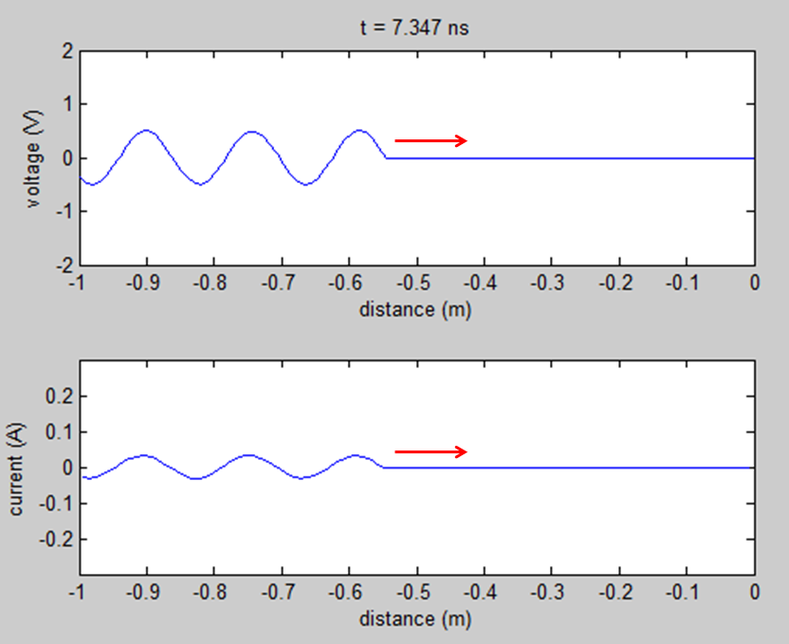

**Figure 2:** Voltage and current plots showing a sinusoidal wave propagating down a transmission line excited at one end by a sinusoidal source.

Note that the simulation responded according to the boundary conditions. For example, if the termination resistance $\left(R_{L}\right)$ was less than the characteristic impedance of the line $\left(Z_{0}\right)$, then the reflected voltage wave was inverted, as shown in Figure 3. Similarly, if $R_{L}$ was greater than $Z_{0}$, then the reflected voltage wave was not inverted. Finally, if $R_{L}$ was equal to $Z_{0}$, then the load was matched to the line and no reflection was observed.

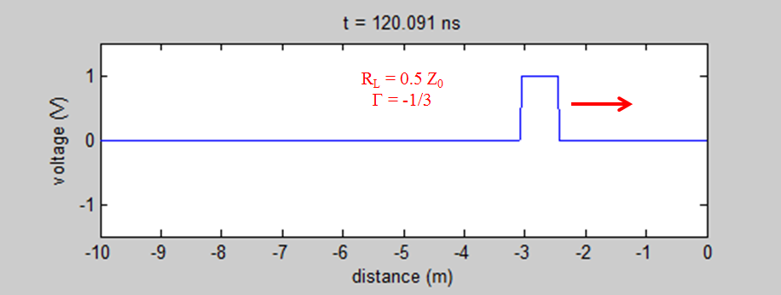

**Figure 3a:** Voltage pulse approaching the termination with $R_{L}={\frac{1}{2}Z}_{0}$.

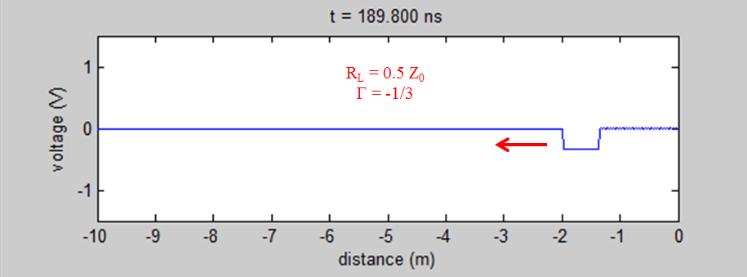

**Figure 3b:** Voltage pulse after reflecting off the termination. Note that the pulse has been inverted because $R_{L}<Z_{0}$ and it has been reduced to $1/3$ its original amplitude due to the lossy termination resistance. The reflection coefficient is $Γ=-1/3$.

1. **Results**

It was found that higher-order derivative approximations did not improve accuracy. Generally, higher-order accuracy can be achieved by including additional non-adjacent nodes in the difference equation, as discussed in [1]. However, it was discovered that wave phenomena do not benefit from this improved accuracy. For a given node, including extra non-adjacent nodes in the difference equation causes the node to “see” the wave before the wave actually arrives at that node and therefore causes the node to respond too soon. This can cause unwanted spikes or oscillations to occur in the solution, as shown in Figure 4.

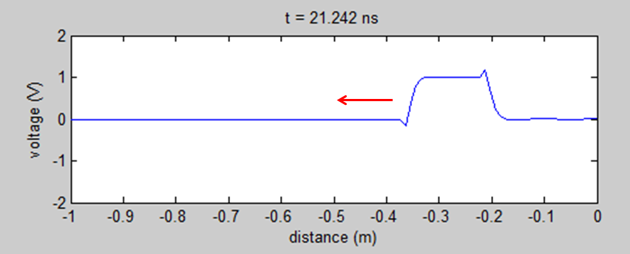

**Figure 4:** Higher-order derivative approximations included in the boundary condition cause unwanted spikes to occur in a square pulse after reflection.

Collocated (discrete voltages and currents defined at the same locations in space and time) techniques were unstable unless averaging was applied, which caused square pulses to be rounded after reflecting off the termination, as shown in Figure 5.

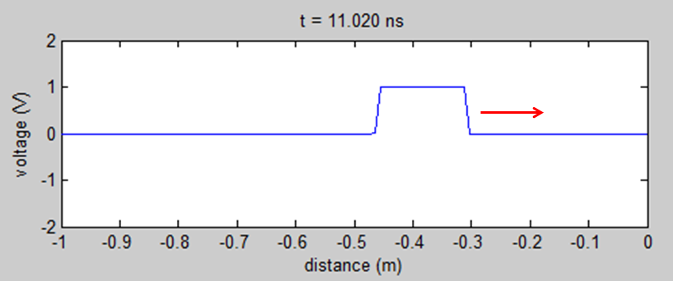

**Figure 5a:** Square voltage pulse approaching a short circuit termination (collocated).

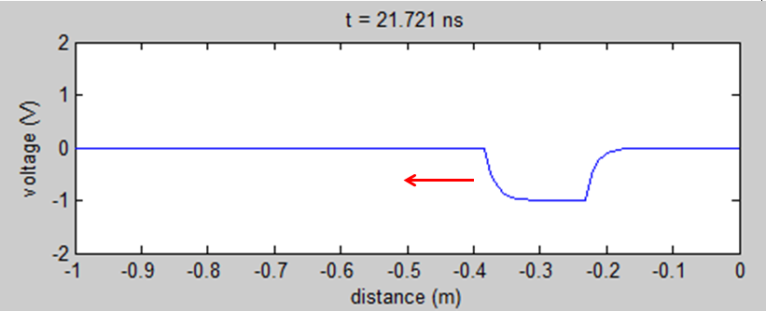

**Figure 5b:** Voltage pulse that was originally square becomes rounded after reflecting off the termination. This is an artifact of the averaging technique that is required for stability of the collocated solution.

Un-collocated (discrete voltages and currents staggered in space and time) techniques, on the other hand, were stable without averaging and therefore did not suffer from the rounding effect. Notice in Figure 3 how the pulse retains its square profile even after reflecting off the termination. As explained in [2], the un-collocated solution had second-order accuracy under ideal conditions.

One major motivation for researching the FDTD method as a tool for simulating transmission lines is that it provides a relatively simple solution to a complex mathematical problem—a problem that becomes even more complex when the line parameters ($C'$, $L'$, $R'$, and $G')$ are not constant, but vary with the spatial dimension ($z$). This occurs when either the materials or the geometry of the transmission line are not uniform over the entire line. At first glance, it seemed simple enough to modify equations (3) and (4) so that the $C'$, $L'$, $R'$, and $G^{'}$ terms refer to a profile of line parameters indexed by the spatial index ($m$). However, it was quickly discovered that it is not so simple. Non-uniform line parameters imply that the wave propagation speed, dictated by $u_{p}=\frac{1}{\sqrt{L^{'}C^{'}}}$, is also non-uniform over the entire transmission line. Interestingly, the ratio $∆z/∆t$ is directly related to the wave speed—this relationship is known as the Courant-Fredrichs-Lewy (CFL) stability limit [2]. The ramifications of the CFL stability limit are that the second-order accuracy of the central differences can only be maintained for a specific $∆z/∆t$ ratio equal to the wave propagation speed. When simulating a transmission line with non-uniform line parameters and non-uniform wave speed, it seems that either $∆z$ or $∆t$ would need to be altered for a portion of the line in order to maintain second-order accuracy. Further research is required to determine how to accomplish this practically. However, a special case was observed where the line parameters were non-uniform but the wave speed was constant for the entire line, as shown in Figure 6.

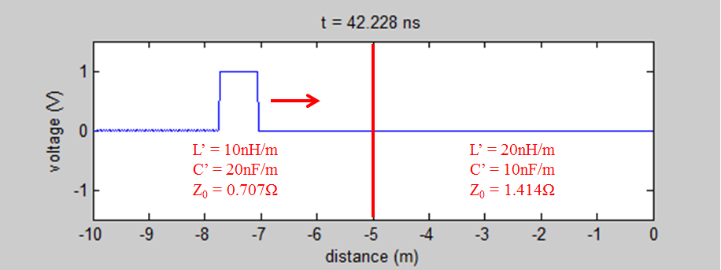

**Figure 6a:** Voltage pulse approaching the characteristic impedance discontinuity.

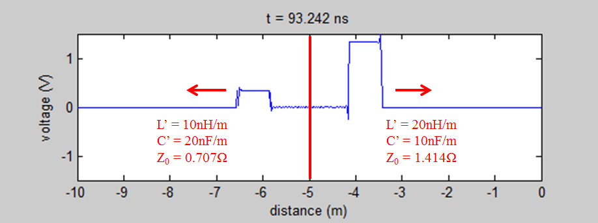

**Figure 6b:** Reflection coefficient is $Γ=\frac{Z_{02}-Z_{01}}{Z_{02}+Z_{01}}=\frac{1.414-0.707}{1.414+0.707}=1/3$. Transmission coefficient is $T=Γ+1=4/3.$ However, note that the wave speed is $u_{p}=\frac{1}{\sqrt{L^{'}C^{'}}}$, which is constant for the entire line.

1. **Conclusions**

A computer program was successfully developed using the FDTD method to simulate a 1-dimensional transmission line. Boundary conditions were successfully developed, allowing any voltage source to be simulated along with any combination of source and load resistances. Higher-order derivative approximations did not improve the accuracy of the simulation. The un-collocated solution proved to be more stable and more accurate than the collocated solution. Complications were encountered regarding the simulation of non-uniform transmission lines—there is a strict relationship between $∆t$, $∆z$, and the per-unit-length parameters ($C^{'}$, $L'$, $R'$, and $G'$) that must be enforced in order to maintain second-order accuracy. Thus, the simulation of a non-uniform transmission line requires that either $∆t$ or $∆z$ be non-uniform. An adaptive algorithm to implement this efficiently is a potential topic for further research.

1. **References**

[1] Chapra, Steven C. Applied Numerical Methods with MATLAB for Engineers and Scientists. Boston [etc.: McGraw-Hill Higher Education, 2008. Print.

[2] Gedney, Stephen D. Introduction to the Finite-Difference Time-Domain (FDTD) Method for Electromagnetics. 1st ed. Morgan & Claypool, 2011. Print.

[3] Ulaby, Fawwaz T. *Fundamentals of Applied Electromagnetics*. 5th ed. Upper Saddle River, NJ: Pearson Prentice Hall, 2007. Print.